New Family Profile with Previously Used USPS Address - 6/20/23
3 months ago Updated
FollowNot yet followed by anyone
Problem:
The family is creating a family profile, but the system already has a family account with the same mailing address. The new family is not able to recover the account, because the account recovery phone number is not theirs. How can you create the new family's account so they can enroll in your program?
Background Info:
The system prevents families (but not managers) from verifying mailing addresses on new profiles when the mailing address is already tied to a family profile in the system. This typically happens when:
- A family has moved from their former address, but the mailing address has not been updated. A NEW 4-H family now moves to that same address and is creating their account, they will get a notification that there is a duplicate account.
- An individual has aged out of a youth program and wants to create their own family account (separate from parents/siblings) to volunteer in a program, but they continue to live at the same physical address.
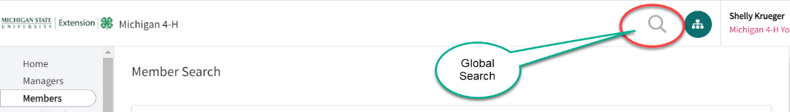
Solution:
To resolve this duplication, the Manager should locate the new family profile that has been started by the family via the Global Search.

- Search for the family's email address and view the profile.
- Click on Family in the navigation pane.
- Enter the mailing address for the family and click Verify.
If the new family profile has not yet been attempted to be created, the manager can create the new family profile (Create Family) on the Members Search screen and will not receive the duplicate account notification.

